**Comparing Drugs Trade on Tor in Finnish, English, and Polish Speaking Cultures**

Mikko Aaltonen, Angus Bancroft, Ari Haasio, Tuomas Harviainen, Juha Nurmi, Haitao Shi, Piotr Siuda

*Abstract: Within the Tor network, we compared the Finnish, English and Polish drug trade. To accomplish this, we selected three new and active onion sites. A Finnish site within the Tor network offers an anonymous chat, “Tsatti”[1], messenger and chat rooms for the biggest towns in Finland. Most of the messages are associated with the illicit drug trade. Similarly, the Polish forum website “Cebulka” operates anonymously within Tor and facilitates drug trafficking[2]. Established in 2021, “Nemesis” is a combination of a darknet market and a forum[3]; in addition, the products are displayed publicly and registration is not necessary. We employ datasets that web crawlers retrieve from these websites, develop criteria to evaluate the trade culture, and discover significant differences between the trade cultures.*

Keywords: Illegal drugs; Tor; Anonymous trade; Culture

**Introduction**

This article examines, with examples from three countries, localized differences in online drug trading. Until recently, research on the topic has focused mainly on cryptomarkets, from which people pseudo-anonymously order illegal narcotics (e.g., REF). Those sites, while prominent, have been only one part of the larger picture (REF). Using multiple method analyses, this article demonstrates that local drug culture, differences in site access, and drug availability all have significant influence on how trading is conducted. These differences call for new, broader variance in the study of drug trading. Our goal here is to provide a research agenda for that purpose, as well as present examples of tools through which new relevant data on the topic can be found.

Although drug markets in Tor are studied and related literature analyses X and Y, there is no foundational research to compare drug trading amongst national cultures. Additionally, past studies, like ABC did not publish data or exact methodology to compare drug trade cultures. We fill this research gap and propose the following research questions:

RQ1: How to compare drug trade cultures systematically, and what factors to measure?

RQ2: How do the Polish, Finnish, and English markets appear using these variables?

RQ3: What are the most significant distinctions between these drug trade cultures, and what are the implications of those distinctions for further research?

***Cebulka*: a short description**

According to the information from *Cebulka*, the site has operated since 2013 as the successor of the now-defunct *Polish Board & Market*, and survived the closure of other Polish dark web markets, i.e., *Poligamy*, *Polish Onion Palace,* and *ToRepublic*. Initially, the site was not moderated, but in 2016 PGP keys and Escrow were introduced. For Cebulka, it is essential to distinguish posts/threads from offers. Cebulka is a board/forum with threads open by vendors, and a given vendor may use several posts to sell different kinds of drugs or use only one thread for all types. In case the given post is about many offers, the comments below either refer to all of them (positive or negative experience with a vendor as such) or a particular substance bought. There are no indications about the regions of Poland where the sellers operate, nor is there any information on whether they sell to particular locations (e.g., particular cities). One may say this is a general Polish board, and the transaction may be successfully carried out regardless of buyer and seller location. As of August 31, 2023, there were 52,418 registered users.

**Data**

*English: Nemesis Market*

<http://nemesis555nchzn2dogee6mlc7xxgeeshqirmh3yzn4lo5cnd4s5a4yd.onion/> “Nemesis'” Market offers illegal products. Data consists of 1,334 pages. We collected these pages in December 2023. One page represents one selling advertisement message in this case.

*Polish: Cebulka* (<http://cebulka7uxchnbpvmqapg5pfos4ngaxglsktzvha7a5rigndghvadeyd.onion/>). 965 advertisement pages from the “Cebulka'” onion website in Polish were collected in January 2023.

*Finnish: Tsatti*

<http://tsattickdplsh2i2xqzlybvreiuppgoqsicmzkrotuudnk7h665ukgid.onion/> 1,500 messages from the Finnish onion website “Tsatti”. We collected these in November and December of 2022. There are several messages on one page and most of the messages are associated with the illicit drug trade. The site deletes old messages automatically, which is why only temporary snapshots of it can be acquired for research.

We compile and publish three datasets, freely available to the academic community.

The datasets are under CC BY 4.0 license:

You are free to copy, share, redistribute, remix, transform, and build upon the material

for any purpose, even commercially. You must give attribution and appropriate credit.

Follow the terms: <https://creativecommons.org/licenses/by/4.0/>

Datasets are available on <https://mega.nz/folder/CNAlwJ7a#SkJ2XAuOe-ew9YpMSMA8Pg> – There are three compressed folders: Finnish.zip contains the Finnish data from “Tsatti'”, Polish.zip contains the Polish data from “Cebulka”' and English.zip contains the English data from “Nemesis'”. Uncompressed data contains all of the web pages in a JSON file in a machine-readable format, screenshots from the websites and a “textpages” folder contains readable text versions of the web pages.

**Methodology**

*Finnish: Tsatti*

We gathered information using web crawlers. We converted these HTML web pages to text format (using the Python html2text library). We further processed the

Finnish chat discussion messages to JSON format, with each message representing a single JSON file with all metadata. For data extraction, we wrote Python software with regular expression rules and ad hoc language checks that broadly matched Wickr nicknames, Session IDs, and sales articles. We manually verified the extracted data for the sales messages.

XXX To be added here: which approaches were used in which country and why (to convince readers, in this way too, that localization of approaches is necessary).

*English: Nemesis Market*

The dataset, scraped from Nemesis between 1st January to 11th January, contains 1334 files comprising 607 posts on drug sales, 415 posts on fraud, 134 posts providing guides and tutorials on illegal activities, and other miscellaneous posts. In this analysis, we will focus solely on the drug sales-related posts.

Tidyverse packages was used in R to delete irrelevant files (i.e., those without the keyword "drug") and regular expressions were used to extract useful information from the remaining files. Missing values were handled, and all files were saved in a tidy format as a CSV file. The column names are File_Name, Title, DrugName, BrandName, Drug_Type, Rating, Reviews, Sales, Ship_From, Ship_To, Ship_Methods, Availablity, Drug_Type_L (drug type in a broader classification), MainContent (the description of drug), Refund, Review, and Vendor_Name. In addition, the thematic analysis was conducted utilising the MAXQDA software.

*Polish: Cebulka*

336 threads/posts out of 965 scrapped were identified as associated with the illicit drug trade with 165 unique vendors’ handles. For the threads, subcategories were identified and connected to broader categories, to give a comprehensive idea of Cebulka’s content. Some categories are introduced in the Results section, e.g., types of drugs, “communication with the vendor,” “payment method,” “shipping method,” “shipping time,” “sales conditions,” and “loyalty discounts.” Then, using MaxQDA software, the categories were assigned to offers, making possible variables analysis and examining monotonic relationships (non-linear ones). For testing, Spearman’s correlation coefficient was used. Also, some natural language processing (NLP) word frequency analysis was implemented. The textual corpus was built from 336 offers, then lemmatized word frequency lists were created. This was done to identify the so-called trigger words, the most frequent and relevant words in terms of the research questions. These words were identified for each category to enrich the statistical analysis.

Additionally, from February to August 2023, the Polish research team used non-participatory netnography (Kozinets, 2009), which is a unique form of ethnography dedicated to the study of online communities. This part of the research was intended to take a closer look at all scrapped threads related to the drug trade, but it focused not only on offers but also comments, including following links to Cebulka’s threads that are not advertisements but relate to other issues (see the Results section). The procedure of this non-participatory nethnography (no interactions with users were initiated) was to analyze both the scrapped content and field notes made for each offer, the comments below the offers, and other parts of the forum mentioned in these comments. Team members used forms to describe and code the content, and present their notes, and interpretations while being there on-site.

**Results**

*Finnish: Tsatti*

We analysed all Finnish chat messages. 977 of 1574 messages are advertisements. There are 358 unique nicknames on Wickr and 36 unique Session IDs for vendors. Session ID is an alternate contact method in addition to the Wickr nickname. Thus, there are a total of 358 unique sellers.

|  |  |
| --- | --- |
| **Category** | **Sell advertisements** |
| prescription_drugs | 386 |
| cannabis | 299 |
| lsd | 7 |
| opioids | 268 |
| accessories | 9 |
| cocaine | 44 |
| mdma | 167 |
| amphetamine | 198 |
| mushrooms | 79 |
| ketamine | 35 |
| methamphetamine | 40 |
| gamma | 2 |
| steroids | 9 |
| viagra | 12 |
| 5-meo-dmt | 12 |
| tobacco | 4 |
| sex | 4 |
| A-pvp | 3 |
| 2cb | 3 |
| dob | 3 |

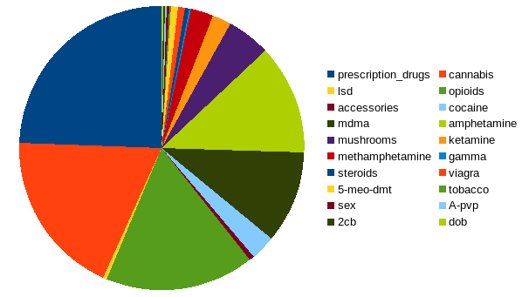

The vendors typically specialize in one type of substance, as 71% percent of them sell only one type, 17 percent two types, and only few sellers more than 4 different substances. The sellers who are most likely to specialize are the ones selling MDMA (65% of vendors selling one substance only) and cannabis (58%), whereas vendors selling mushrooms (28%), opioids (32%), and cocaine (33%) are more likely to sell other substances, as well. For example, 23% of vendors who sell cannabis also sell prescription drugs, while the proportion selling prescription drugs among those who sell opioids is 51%.

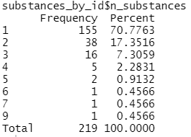

While some of the vendors post advertisements on topics in different geographic regions, 64% of vendors only sell in one geographic area. Fairly many sell in two (15%) or three (12%) regions, but there are only a few nicknames that appear in more than 5 different regions. The regions with the highest numbers of unique handles are the cities in the Helsinki metropolitan area (Helsinki 50, Espoo 47, Vantaa 47), followed by Tampere and much smaller southern cities of Järvenpää and Kerava. The order of the cities does not thus fully follow their population size, which may suggest that there are some regional differences in the popularity of the service.

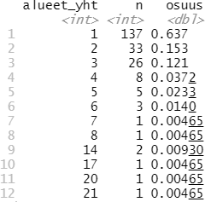

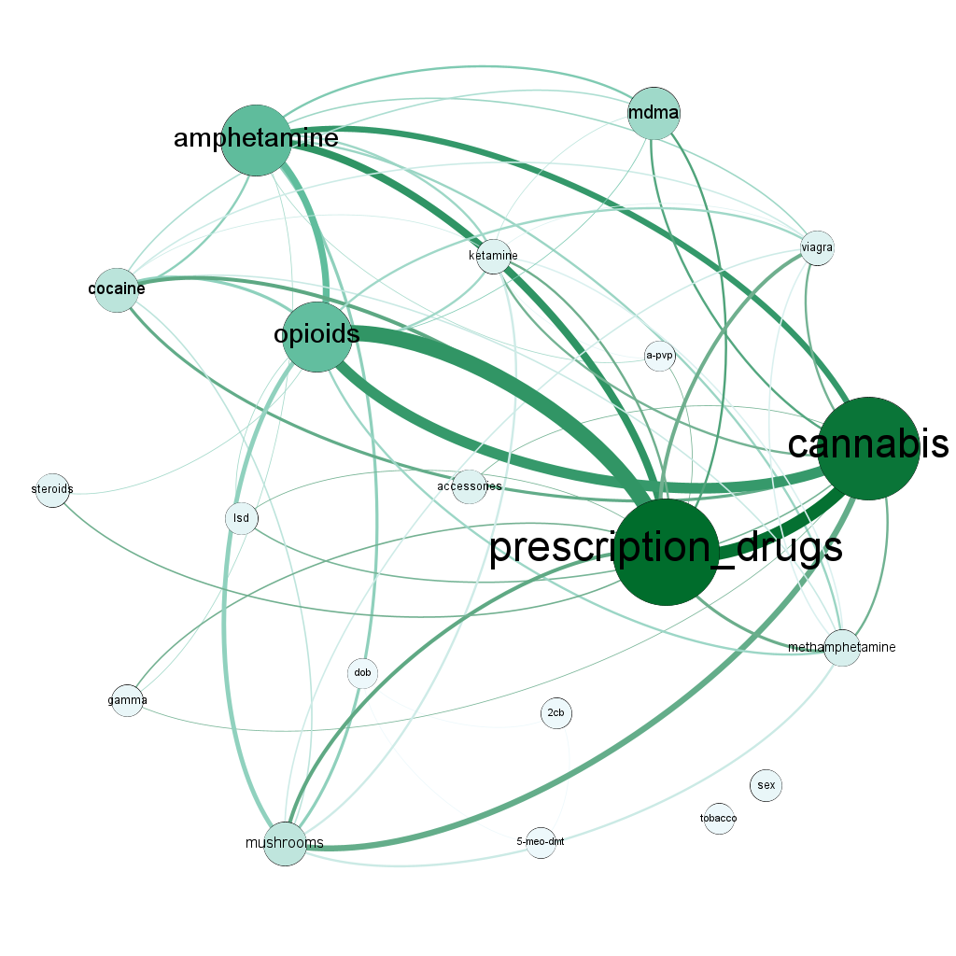

**Preliminary outlining/Haasio & Harviainen**

**DISCOURSES OF SPEECH REGARDING DRUGS ON THE DARK WEB**

**1.** **Introduction**

**2.** **Previous literature**

**3.** **Research questions and methods**

The material has been analyzed using qualitative content analysis. Our main research questions are:

1) What are the main discourses of the dark web drug trade talk?

2) How have the expressions of information sharing, and information needs possibly changed?

We analyze the change in online speech between the results obtained in previous studies (Haasio, Harviainen & Savolainen, 2020; Haasio, Harviainen & Hämäläinen, 2022) and the material analyzed now.

**4.** **Results**

**4.1** **What are the characteristics of online speech related to the drug trade?**

Whereas in previous discussions, in addition to dark web drug vending, questions related also to drug culture (books, music etc. about drugs), health-related problems, the cross-effects of different substances and the experiences of drug “trips” were discussed, a clear change in the contents of the discussions can now be observed in the analyzed material. In the material we analyzed, the discussions are practically focused on the pure drug trade. Cultural discussion and the sharing of one's own experiences about problems other than drug dealing are completely missing.

Four main themes can be distinguished from the materials, which are represented in the messages. These themes are marketing, security, location and the quality of the products. Examples of each of the four themes have been collected in Table X

***Table X. Main themes of information needs and information sharing***

|  |  |  |
| --- | --- | --- |
|  | **Information need** | **Information sharing** |
| **Marketing** | Examples | Examples |
| **Safety** | Examples | Examples |
| **Location** | Examples | Examples |
| **Quality** | Examples | Examples |

When comparing the Wickr-aliases to the previous material analyzed, the decrease in the number of individual sellers is noteworthy.

***Marketing.*** Compared to previous online forum discussions, there has been a clear change in marketing. Now it is primarily based on informative product information. Earlier, the marketing speech made more use of praise and glowing in describing the effects of the product. Sure, it's still there, but the more informative way of speaking has clearly increased.

EXAMPLES

In addition to sales announcements, the previously examined Finnish dark web drug websites also had plenty of purchase announcements. Now, the latter are almost completely absent. There are some announcements in which, first of all, you inquire about the availability of a particular drug or the availability of drugs more generally in a smaller town.

EXAMPLES

In past studies, we noticed that many vendors got feedback on both their product and trustability. Especially if the seller was relaxed and the transactions went smoothly, the buyers gave positive feedback. Correspondingly, if the product was not as expected or there were difficulties with the seller, others were informed about it. Now, there are considerably fewer of these patterns in the material we are analyzing.

The same messages were repeated often in the sample. In practice, they were sent to message threads in different cities following the copy-paste principle. This is a clear change compared to previous Finnish sales announcements. In them, the phenomenon was not so clearly noticeable.

***Safety.*** In the Finnish drug debate, racism and trust are central elements. Many announcements say that the seller "is prepared for rats", which practically means taking precautions to prevent robbery attempts and scams. It is remarkable, that in many advertisements the vendors underline that they don’t do business with immigrants or gypsies. In some cases, they also declare that they are Finns, in other words white native population.

There is quite a bit of discussion in connection with announcements. In some cases, a buyer may have commented specifically on the seller's reliability and ethnicity.

***Location.*** The same vendors operate in different parts of the country, even though the distance may be hundreds of kilometers. Their announcements are in connection with several different cities. In the previous materials we analyzed, the sellers were almost without exception focused on a specific area. This is noteworthy because the lots sold are generally relatively small. In big cities several vendors may focus their marketing on a certain part of the city.

It is also interesting that the reliability of almost all sellers is questioned at least once, and others are warned against them.

***Quality.*** As has been stated before, there was less hype about the effects of commercial drugs. Some announcements had it, as can be seen from the following example:

EXAMPLE

Instead, they tried to convince buyers of the quality of the drugs by talking more about their properties: for example, the cannabis strain was often mentioned. Haasio et al. (2022) have noticed the same phenomenon when studying the marketing speech on the dark web. sellers are wary of both authorities and customers. Selling and possessing drugs is a punishable act in Finland. That's why safety and trust are key in trading. In some cases, scams and robberies are also things to watch out for in a sales event.

EXAMPLE

*English: Nemesis Market*

**Results**

**The payment method**

Bitcoin and Monero accepted. All items are listed as an escrow. The order process is as follows:

* After the buyer has placed an order, the vendor has 5 days to accept or reject the order.
* The buyer will get a full refund if the vendor doesn’t accept the order within 5 days.
* If the buyer doesn’t want to wait 5 days, there will be a cancel button after 48 hours to cancel the order and get a full refund.
* After the order got accepted, the vendor has 5 days to send it. The buyer can not cancel the order at this point.
* The buyer will get a full refund if the vendor doesn’t send the order within 5 days.
* The buyer has 3 days to open a dispute if the order does not match the description.
* After the order got finalized, the buyer can leave a review.
* If you have any questions, leave a comment or create a post on our forum.

Bitcoin and Monero are accepted as payment, and all items are listed as an escrow. The order process includes a set time for the vendor to accept or reject the order, with options for refunds. If an order is received that is not as described, it can be disputed within a limited period, and the buyer can leave a comment once the order has been finalised.

**The number of posts of each type of drugs (Top20)**

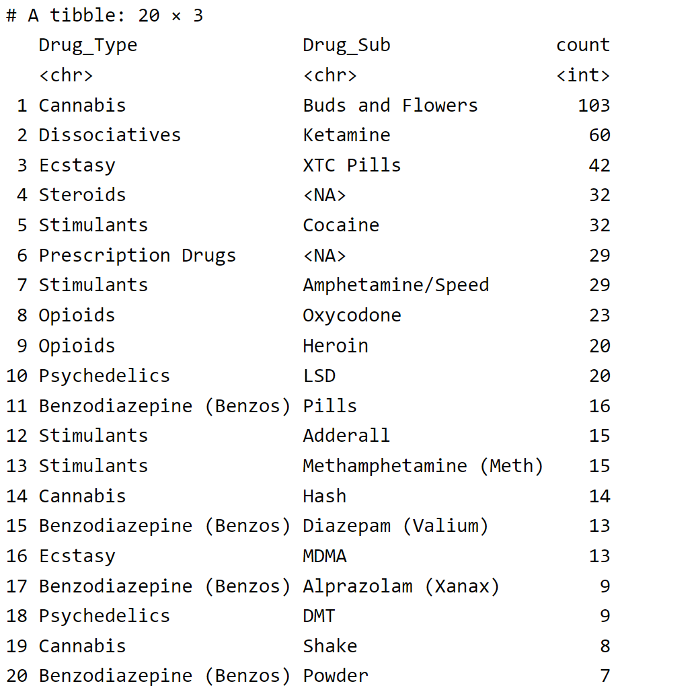

Different types of drug are sold in Nemesis, namely, Cannabis, Dissociatives, Opioids, Steroids, Psychedelics, Stimulants, Prescription Drugs, Benzodiazepine (Benzos), Ecstasy, and others. Some drug type has specific subcategories associated with it. For example, under the drug type Cannabis, the subcategories include Buds and Flowers, Hash, and Shake. The “count” column represents the number of posts for each drug subcategory, indicating the frequency or popularity of each drug subcategory. For instance, the drug subcategory “Buds and Flowers” has a count of 103, and it has the highest number of posts among all the drug subcategories listed. Dissociatives (Ketamine), Ecstasy (XTC Pills), Steroids, and Stimulants (Cocaine, Amphetamine/Speed) also have significant counts, suggesting their popularity in the market.

**The number of posts of each drug (Top20)**

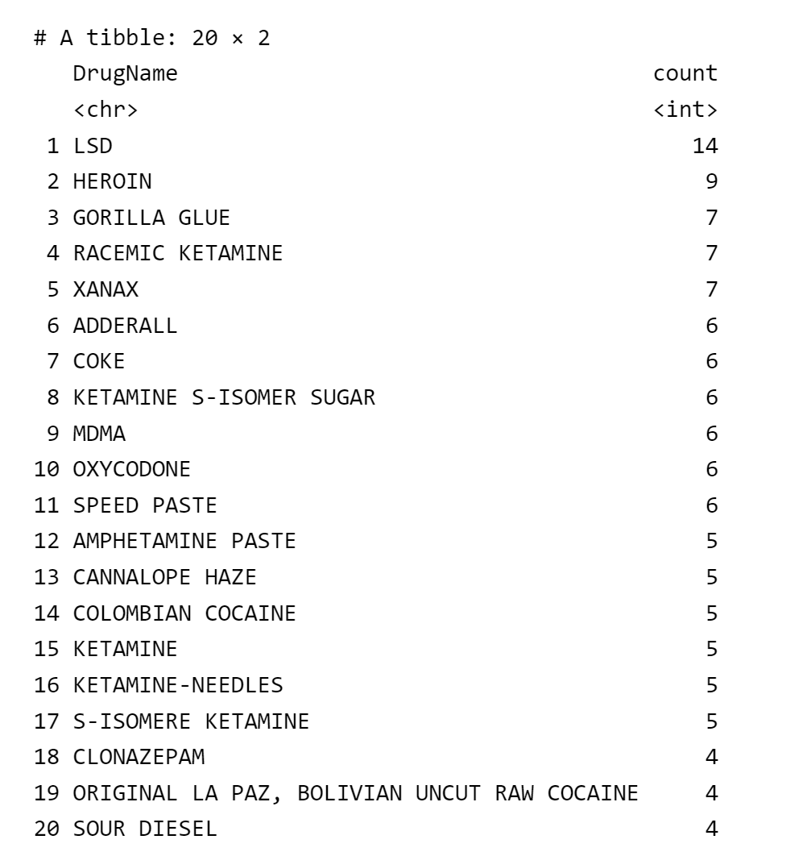

The data frame consists of the top 20 drug names mentioned in posts. The “count” column represents the number of posts for each drug. It can partly indicate the popularity of each drug. Based on the counts, we can see that LSD (n=14), Heroin (n=9), Gorilla Glue (n=7), Racemic Ketamine (n=7), and Xanax (n=7) have relatively higher counts, suggesting a higher level of discussion or interest in these drugs.

**The brand name of the drugs for sale**

The table below shows each brand name and its number of occurrences, and it can be observed that MONSTERLAB and HYDROGURU are the brands with the highest number of occurrences. These two brands are not specific to any particular drug, but rather the names of the labs. It seems that they have generated a certain brand effect, representing a guarantee of high-quality drugs.

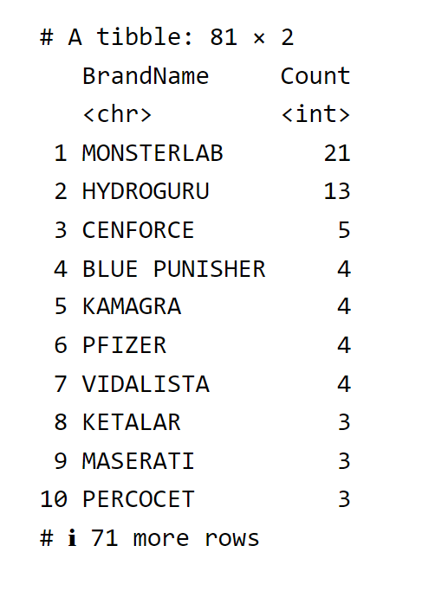

**The brand name of XTC Pills**

Another interesting observation is that the brand name of XTC Pills may indicate the strength or purity of these drugs and also provide a guarantee of quality for buyers. For instance, ORANGE TESLA with the warning “strong, be careful!” (01025.txt) may harbour more potential strength compared to Pink Glitter Tesla, with the description “very clean and stimulating” (00307.txt). While almost all vendors selling XTC Pills highlight the “high quality” of their products, some emphasise that their XTC Pills have been “lab tested” (13 out of 42 posts) or “black light tested and reagent tested with Marquis and Froehd” (00458 and 01025). Such measures in place serve the primary role of ensuring top-notch quality and utmost safety.

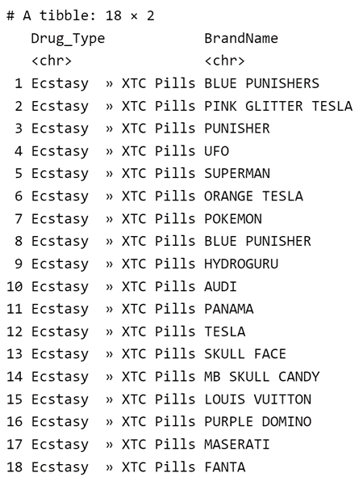

**The availibility rate**

It is worth mentioning that not all drugs available on the market are actually available on Nemesis Market. According to the dataset provided, the availability rate of drugs on the Nemesis Market is 95.87%. This may be due to reasons such as the drug being sold out or the drug vendors being on holiday.

**Ship Methods**

* DECOY STEALTH: deceptive tactics to divert attention away from the real items being transported. (e.g., False labeling, deceptive packaging)
* NINJA STEALTH SHIPPING: a highly covert and discreet form of shipping. It uses a variety of strategies to ensure that the parcel remains undetected and does not arouse suspicion. (e.g., unmarked packaging and the strategic placement of items within the parcel.)
* Express Stealth: fast delivery options to ensure quick transportation while still employing stealthy packaging techniques.
* Stealth + Decoy + Priority: It implies using various concealment techniques, diversionary tactics, and expedited shipping to ensure both discretion and speedy delivery.

Vendors' shipping methods mainly include the following types, namely, Discreet Shipping, Decoy Stealth, Ninja Stealth Shipping, Express Stealth, and Stealth + Decoy + Priority. Despite the different names, it is clear that vendors use various strategies to ensure that the parcel remains undetected and does not arouse suspicion. The strategies may include false labelling, deceptive packaging, unmarked packaging, and the strategic placement of items within the parcel. This also implies that the speed, discretion, and security of shipping are important factors for buyers to decide whether to purchase or not.

Shipped by courier:

* Royal Mail (First class/First class tracked/Free NDD/UK SPECIAL NDD). NDD stands for Next-Day Delivery
* Canada Post / Canada Post Xpress
* DE to DE (this is domestic shipping within Germany)
* Deutsche Post
* DHL
* DPD
* France suivi
* USPS (domestic/express/express(stealth+)/priority/normal)
* UPS
* Worldwide RMS/EMS

**Rating, Reviews and Sales**

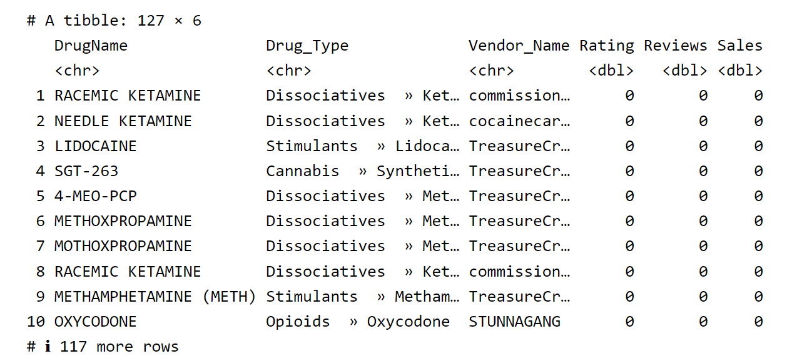

127 drugs have never been sold, so it would be better to remove them before analysing the relations between ratings, reveiws and sales.

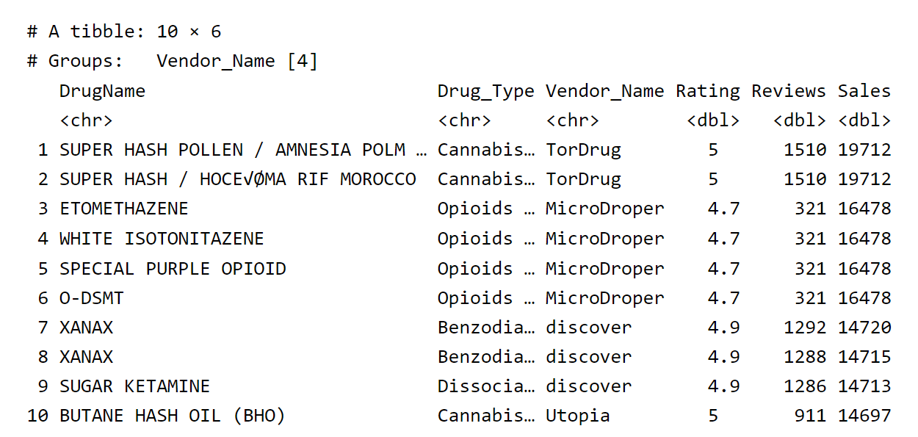

From the data frame above, we can see the drugs sold by the vendor are different, but the number of Rating, Reviews and Sales are the same. Thus, one important point here is that the ratings, reviews, and sales displayed on each post are not specific to the drug being sold itself, but rather pertain to the vendor. In other words, the ratings, reviews, and sales are a comprehensive evaluation of all the products sold by a vendor. This design reflects to a certain extent the importance and uniqueness of trust in the illegal market. In an environment without legal protections, the reputation of the individual vendor becomes particularly important, and may even outweigh the quality of the specific product itself. Unfortunately, since each vendor may sell different types of drugs, it would be statistically impossible to know the best-selling drug types, highest-rated drug types, or the types of drugs that receive the most reviews.

As previously indicated, the data collection period extends over a span of 11 days. It is important to note that trading activities were taking place throughout this duration, resulting in fluctuations in variables such as ratings, sales, and reviews. For instance, a comparison of the reviews and sales numbers for the vendor XANAX （line 7 and 8) reveals minor disparities. Consequently, I retain the row containing the highest sales number as the definitive value for the rating, reviews, and sales of each vendor.

**The statistical information about ratings, reviews, and sales.**

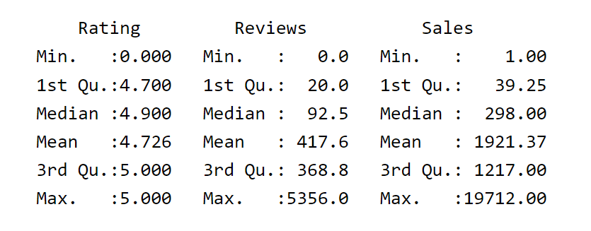

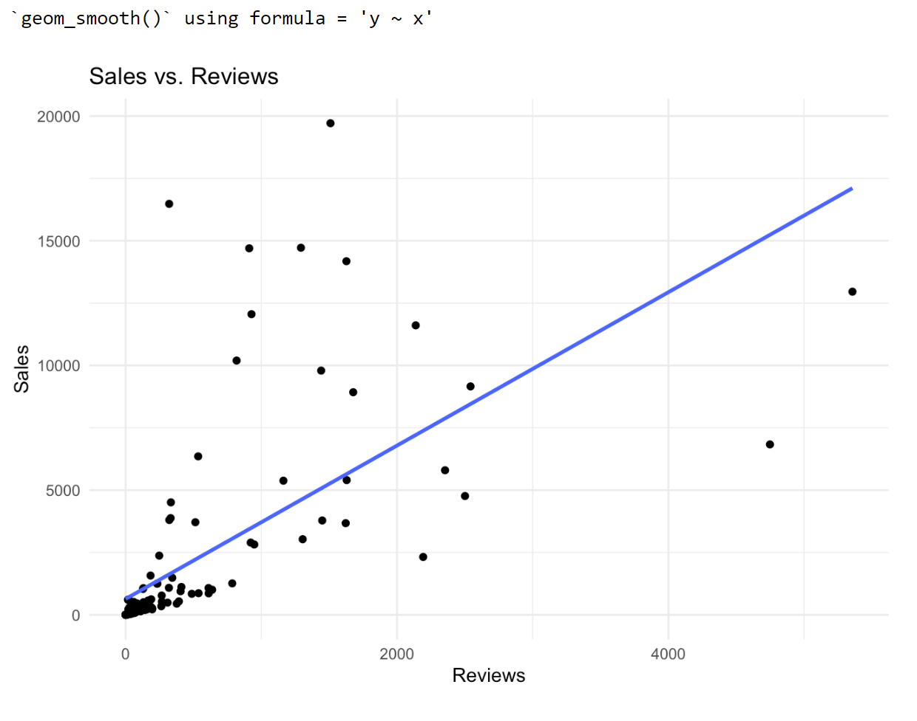

The correlation between the number of reviews and the number of sales is the strongest, with a correlation coefficient of 0.646. This means that an increase in sales is likely due to an increase in the number of reviews. The correlation between the number of reviews and the rating is weak, with a correlation coefficient of 0.148. The correlation between the number of sales and the vendor rating is also weak, with a correlation coefficient of 0.138. This indicates that rating may not have a significant impact on the increase in number of sales.

**Multiple Linear Regression**

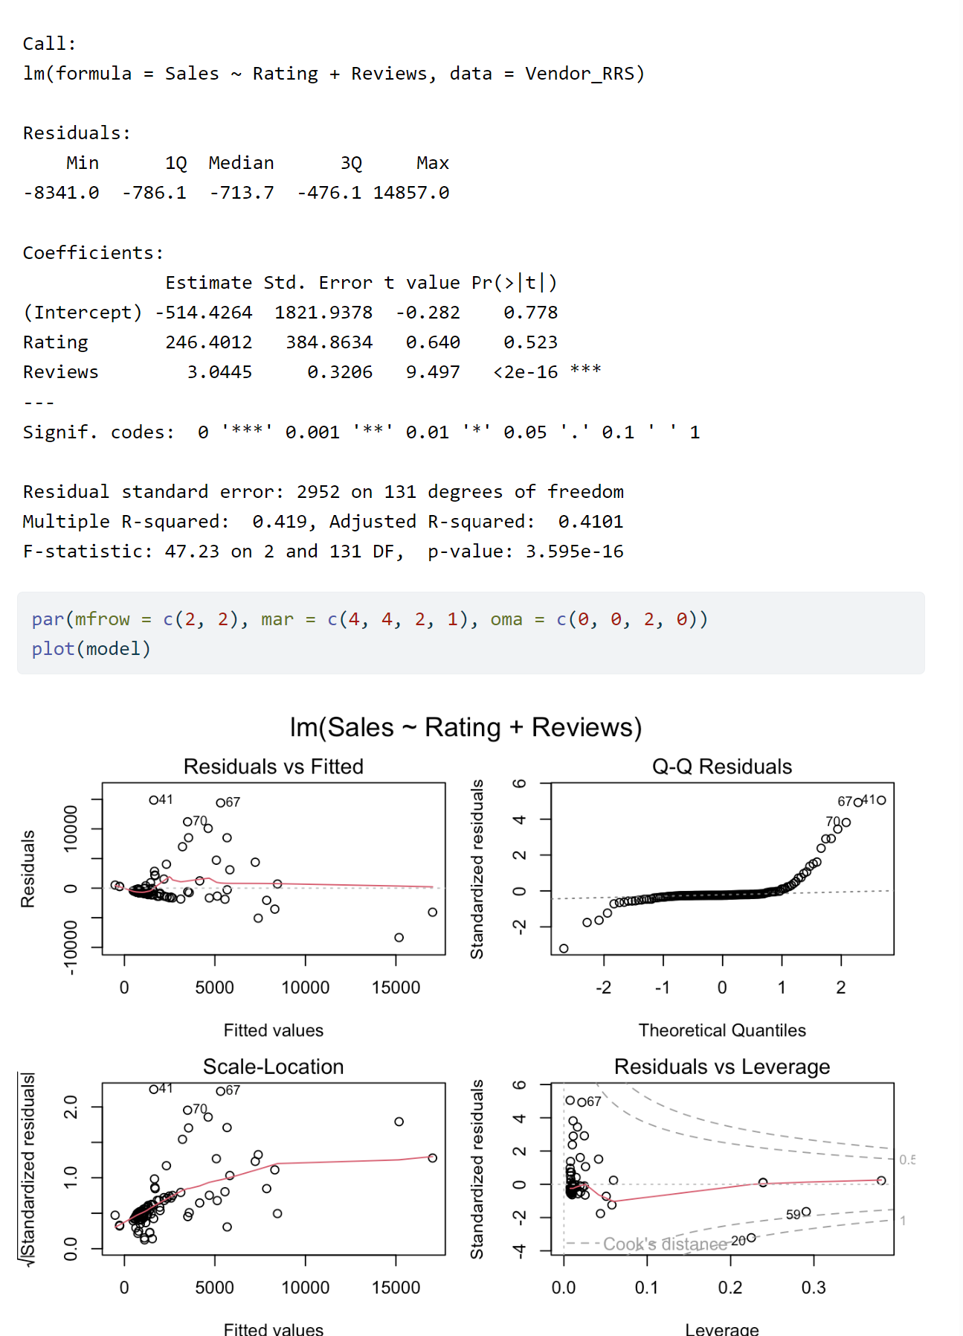

Although the model only explains 41% of the variation in sales (R2 > 0.7 indicates a good fit of the model), the linear regression model demonstrates that the impact of Reviews on sales is significant, whereas the impact of Rating on sales is not significant.

**Top 10 vendors based on sales**

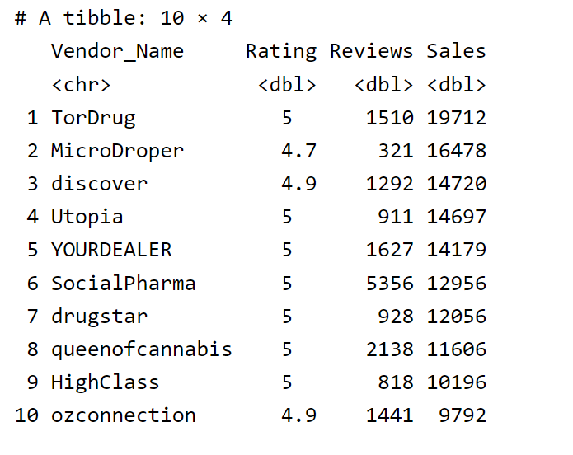

By comparing sales figures, we can identify that the top 10 sellers are TorDrug (19712)，MicroDroper (16478)，discover (14720)，Utopia (14697)，YOURDEALER (14179)，SocialPharma (12956)，drugstar (12056)，queenofcannabis (11606)，HighClass (10196)，ozconnection (9792) . The numbers in the parenthesis are sales on this platform.

We can further examine their advertising, returns policies, and self-introductions to understand why some sellers’ products are more popular and in what ways they gain the trust of buyers.

**TorDrug** (Selling Hash) <00533, 00534>

TorDrug as the top selling vendor has no description of the hash he sells other than the name, and the refund policy is blank. There is no way to tell how he gained trust based on the data provided. Have they gained reputations from other platforms? It’s hard to know.

**MicroDroper** (ISOTONITAZENE and Fentanyl) <00017, 00019, 00496, 00689>

Before describing the products, MicroDroper always introduces themselves to establish trust.

Hey, We are MicroDroper team. 7 years in the Dark Market. Over 16k reviews. 100% satisfaction. We are working with TGC labs (tgchemicals.com) and here to provide for you the best quality of research chemicals on the Darknet. Seems like Nemesis market is the best market place. Our team hope to have good relationships in this market and hopefully they will stay up for a long run!

They emphasise their experience (7 years) in the dark web market, the large number of positive reviews (over 16,000), and high satisfaction rate (100%) to build trust and authority. This is done to attract potential customers and make them believe that they are reliable and professional. However, it is clear that 100% satisfaction is not true as they only have a rating of 4.7, which is the lowest among the top 10 sellers. They highlight their collaboration with TGC Laboratory and emphasise “best quality,” reflecting their attempt to stand out in a competitive market. Their optimism towards the Nemesis market and focuses on establishing relationships reflects their emphasis on market stability and willingness for long-term operations.

They provide detailed descriptions for each product, including composition, purity, and potency. At the same time, they do not conceal the potential harm that the drugs may cause to the human body. On the contrary, we can observe that the information contributes to harm reduction in a broader context. (For me, harm reduction refers to minimising the harmful consequences of drug use and promoting health and dignity of people who use drug.)

Please be careful with this product. IT’S STRONG AND VERY HIGH QUALITY!! (00496, Pos. 49)

isotonitazene can be expected to pose a significant risk of producing life-threatening respiratory depression, as well as other typical opioid side effects such as sedation, itching, nausea and vomiting. (00019, Pos. 48-51)

By providing honest and transparent information about the side effects and dangers of drugs, vendors can, to some extent, build trust. Potential buyers may be more inclined to buy from vendors who are concerned about user safety. Vendors may feel that they have an ethical responsibility to provide accurate information to potential users to ensure that users are able to make informed decisions.

Moreover, MicroDroper adds a customer review in the description.

Customer Review on the product: I tried it Intramuscular as the way I usually run when doing opioids. Felt completely nothing. I contacted TGC and he asked me to try it orally and to let him to know if any effect. and WOW! This works really nicely! I feel great! Euphoria is wonderful! Haven’t felt like this in a while! (00017, Pos. 50-54)

Adding this review in description may positively influence purchasing decisions.

1. This review can build trust, because seeing positive comments can make potential customers believe that the product is widely accepted and effective.
2. Experience sharing (orally in this case) can guide other customers on how to use the product for the best results.
3. The review also indicates that the vendor is responsive and willing to help customers achieve optimal results. This can increase customer satisfaction.

In terms of refund/reship policy, MicroDroper offers a 100% reshipment guarantee, but the maximum amount for reshipment is 500 grams. Buyers are encouraged to place multiple orders if their needs exceed this limit.

**Discover (Alprazolam (Xanax) and Ketamine) <00868, 01067, 01148>**

Although there is no detailed introduction to the product, safety and quick shipping are the selling points of “discover”. They ask the buyer to”encrypt address for safety!” Not only does they draw the consumers’ attention to dosage control, but they also provides methods to minimise harm. For instance,

Be careful, it is strong. Please practice proper safety measures and start small! (01148, Pos. 51-52)

They promises fast and secure delivery and provides 100% Refund if package is seized. However, there will be no refund for the wrong address.

**Utopia** (Cannabis » Concentrates) <00312>

Utopia was the top seller on concentrates. Without detailed description, the vendors stressed their accessibility of providing service and claimed that their products were the “best in Australia”, and all orders were vacuum sealed and posted with tracking.

The only competitor to Utopia is a vendor named GreenConnection (00313, 00315, 00694). They had a sales volume of 4764 and sold a product called Rosin. Unlike Utopia, GreenConnection provided a description of what Rosin was and how it was made. There were also detailed explanations of the cultivation methods, taste, and effects on the body of the raw materials used.

**YOURDEALER (**Amphetamine/Speed) <00644, 01104>

YOURDEALER excels in the trade of speed paste. Despite the scarcity of information regarding the speed paste they offer, YOURDEALER provides a “almost free” tester (approximately 0.5g) for each customer.

Providing free products for customers to experience can enhance interaction and trust between customers and vendors. It also satisfies customers’ curiosity and desire for exploration, making them more willing to try new products. In this process, customers may develop emotional connections with the vendor, thereby increasing their loyalty to the vendor.

Refunds only for regular customers, we ship every order with the highest care and have almost all orders arrived. If a sending is lost and we believe you, it gets reshipped. (01104, Pos. 25-27)

This refund policy helps establish and maintain a trusting relationship between customers and the vendor. Providing refund services only to regular customers can reduce the losses due to dishonest and malicious refund claims. It can also demonstrate the vendor’s commitment to customer loyalty. In other words, it encourages customers to continue shopping with them, thus forming a stable business relationship.

By emphasising the importance of each order and ensuring successful delivery for most orders, the vendor can reduce customers’ concerns about purchasing risks and increase their willingness to buy. This helps to build a positive brand image and attract more potential customers. If any items are lost, the vendor states that they will reship, which helps to maintain customer satisfaction and improve the customer retention rate.

**SocialPharma** (Selling Benzos and Opioids) (00132, 00373, 00483, 00519, 00520, 00721, 00923, 01107)

SocialPharma primarily sell two types of drugs, namely Benzodiazepine (Benzos) and Opioids. Only Oxycodone is shipped from the United Kingdom to worldwide destinations, and it is marked as “non-refundable/non-reshipable.” The other products he sells, namely Zopiclone, Diazepam (Valium), Dihydrocodeine, Codeine, and Tramadol, are sold locally in the UK and have corresponding return and exchange policies. The vendor is a self-employed because he always refers to himself with “me” instead of “us”. Surprisingly, his drug descriptions are often limited to just two lines, specifying the quantity and strength, without mentioning the quality of the products. Similarly, his return and exchange policies are quite brief. He offers either a reshipment or a 50% refund based on the buyer’s purchase time and his own perception of the buyer’s trustworthiness.

Therefore, just like the top seller “TorDrug”, we can assume that the trust generated by the high ratings (all five stars) and a large number of reviews no longer requires him to go through the trouble of describing the product and building trust. In a way, the rating system and sales data have established trust that surpasses the need for product descriptions themselves. Another explanation could be attributed to the types of drugs they sell. Most of these drugs are sold in tablets, which gives limited room for detailed descriptions. This is in stark contrast to vendors selling Cannabis, which will be presented later.

**Drugstar** (Dissociatives » Ketamine, Psychedelics » LSD, Ecstasy » MDMA ) <00369, 00370, 00371>

Welcome to DrugStar your professional drugstore. Active before on Agora and Evolution. 500+ transactions with excellent feedback more currently on Alphabay and HANSA market with these stats 292/5/7) (176/4/4) DREAMMARKET 7000 SALES 4.8+ WALLSTREET 500+ 4.8+ EMPIRE MARKET 9000+ SALES 4.83+ WHITE HOUSE MARKET 1300+ SALES 96,80% POSITIVE ETC. ETC. CHECK RECON FOR VERIFICATION! (00369, Pos. 23-28)

Drugstar is a professional retail company that operates across multiple platforms and sells a variety of drugs. Providing excellent sales data on various platforms is an important way for them to gain the trust of buyers. They offer 24/7 customer service and have the ability to professionally package products and ship them worldwide. In order to prioritise safety, they provide “NO TRACKED SHIPMENTS!” As a result, they only provide

Europe 50% reship in case of no show or 25-50% refund Everything outside of Europe 25-50% reship in case of no show, or 25% refund. No reships if less then 5 total transactions. (00369, Pos. 98-100)

From their descriptions of each product, it is evident that they have a high level of professionalism. All products are thoroughly introduced in the order of a knowledge guide, medical usage, and drug effects. This includes aspects of harm reduction, such as the risks of mixed usage of drugs, the dangers of overdose, and recommendations for safe intervals between drug use.

K-hole and therapeutic effect, hangover zero to none. (doesn’t go well with alcohol) (00369, Pos. 30-31)

At higher doses, however, it reportedly produces a hallucinogenic trance-like state (called a “k-hole”) that is often described as an out-of-body or near- death experience. (00369, Pos. 56-60)

It is usually recommended to wait for one to three months between each use to give the brain adequate time to restore serotonin levels and avoid toxicity. Additionally, using excessively high doses and multiple redosing is highly discouraged as this is thought to significantly increase the toxicity of MDMA. When using, drink enough water, stay hydrated. (00371, Pos. 76-80)

Unlike other vendors, they provide the information about the dosage, duration, and corresponding experience of each drug. For example:

Dosage

ThresholdS+ Isomer 50 mg Light

50 - 100 mg Common

100 - 300 mg Strong

300 - 450 mg Heavy

450 mg+

Duration

Onset 10 - 30 minutes

Come up 5 - 20 minutes

Peak 45 - 90 minutes

Offset 3 - 6 hours

After effects 4 - 8 hours (00369, Pos. 61-82)

These detailed introductions help buyers understand the drugs and prepare themselves physiologically and psychologically before use. They can control the dosage for each use, thus reducing harm to their health.

Another feature of Drugstar is their strong emphasis on customer reviews. They encourage customers to contact them before leaving negative reviews. Additionally, they have established guidelines for writing reviews. They also build their reputation by rewarding those who give positive reviews with additional amount for their next order without additional cost.

**Queenofcannabis (Cannabis » Hash/buds and Flowers) <00530,01094,01194,01200,01205> (no info about refund policy) AND Maurelius(Cannabis » Shake, Hash, and Buds and Flowers) <00028, 00137, 00497, 00498, 00544, 00550, 00553, 00554, 01168, 01170, 01206, 01227, 01240, 01249, 01250, 01253>.**

Although Maurelius is not one of the top ten sellers, it sells wider ranges of cannabis, which can help us to know more about how cannabis is sold. For cannabis sellers, Tetrahydrocannabinol (THC) level is generally provided as an indicator for potency. Numerous paragraphs are dedicated to describing the aroma and taste of each Cannabis product. For example, when describing Afghan Kush (01253), the aroma and taste of this strain are depicted three times in details (01253, Pos. 35-37, Pos. 47-50, Pos. 85-100 ). Furthermore, the heritage/hybrid of Cannabis is also an important aspect that vendors want to emphasise to highlight the rarity and effects of their products. For example:

Alien Cookies is an evenly balanced hybrid (50% sativa/50% indica) strain created through a cross of the popular Alien Dawg X Girl Scout Cookies strains. This bud is incredibly rare to find, but totally worth it every time because of its flawless combination of its parents’ effects. (01240, Pos. 27-30)

The effects of different cannabis products on the body reveal several patterns:

1. Social Behavior and Creativity: Individuals who seek these drugs for their psychotropic effects may seek to experience heightened sociability, amplified ethusiasm and to facilitate creative endeavors.
2. Euphoria and Blissful Sensations: These effects may contribute to a sense of happiness, cheerfulness, and laughter, thereby attracting individuals seeking positive emotional experiences.
3. Relaxation: This combination of physical relaxation and elevated mood may be appealing to individuals seeking stress relief, tranquility, and a soothing experience.
4. Medicinal Benefits: Individuals may turn to these drugs for potential therapeutic effects.
5. Sleep and Sedation: Some individuals may seek these drugs to aid with sleep-related issues or relaxation before bedtime.

Ways to attract purchase or gain trust:

1. Being frankly about the side effects: while dry mouth and dry eyes are often mentioned in the posts, medical adverse reactions are listed.
2. The minimal negative side effects: for example, the vendor points out that Amnesia Haze is a sativa strain with minimal negative side effects compared to other sativa strains, as it doesn’t induce dizziness, paranoia, anxiety, or nausea. The main drawback of Amnesia Haze is dry mouth (cotton mouth), which can be alleviated by staying hydrated before, during, and after cannabis consumption. (see 00497, Pos. 92-101)

Maurelius’s Refund Policy:

“If your order doesn’t show up we can offer you 50% reship or refund of the original order. For years we used to reship 100% of the orders but unfortunately we live in a world where people take advantage of you and sometimes our clients lie when it comes to receiving orders. Please understand that we are here for money and we feel sorry that honnest men/women have to suffer the loss. Besides, you are buying weed, not vegetables. :)”

In the refund policy, it was mentioned that 100% of orders would be reshipped in the past, but later it was changed to only providing 50% reshipment or refund. This indicates the dynamics of the market. Customers who receive the items can still lie and claim that they have not received them in order to deceive for a refund or reshipment. Sellers are increasingly experiencing such negative experiences, which forces them to adjust their return and exchange policies to ensure overall profitability. This return and exchange policy reflects that the trust between sellers and buyers has not been resolved by the escrow method. The sale of drugs is not regulated or protected by law, and buyers and sellers seek a balance of trust through interaction and experience. This is further evidenced by the refund policy provided by SocialPharma, which is based on his perception of the buyer’s trustworthiness.

**HighClass** (00907, 01163)<Psychedelics » LSD，Dissociatives » Ketamine >

Similar to DrugStar, HighClass’s products are also shipped from the Netherlands to the whole world, but they do not provide a detailed description of their products. Not only do they not offer refunds or reshipments in the case of non-arrival, but they also punish those who give them negative reviews - once a negative review is given, the right to a refund or reshipment is lost. They are able to respond to buyers within 24 hours. The following sentences indicate their emphasis on reputation.

I took years building my reputation, it’s sacred to me. I can’t afford negative reviews, especially on a new marketplace. I hope you understand. (00907, Pos. 62-65)

This announcement also reflects the importance of seizing the initiative in a new market platform. In a market full of instability, whoever has a large number of positive reviews first is more likely to form a virtuous cycle. In other words, buyers are unlikely to compare products from multiple sellers, but rather choose to directly purchase from sellers with more positive reviews. For example,

You convinced me to just try this cause you have amazing reviews and I’d like the larger quantity size anyways. O (01058, Pos. 106-109).

**ozconnection** （Stimulants » Methamphetamine (Meth) ）<00741>

I am one of the very few vendors who have been around since the original Silk Road in 2013. I have been a trusted vendor on every major market since then. I always have the lowest price compared to the competition for each product i offer. My quality is consistently high My stock levels are unlimited My feedback is flawless, No exit scamming or Rip Off accusations ever My shipping is always on time My stealth works Customer service is a priority and i will answer every message (00741, Pos. 21-31)

ozconnection does not provide any content related to the product, but instead use self-introduction to enhance their credibility and sales. Firstly, they emphasise their history and extensive experience. They claime to have survived even after the closure of Silk Road, which was once the largest illegal goods trading platform in the world. At the same time, they assert that they have advantages over their competitors in terms of price, quality, inventory, feedback, integrity, shipping, anonymity, and customer service, without any drawbacks or risks. Finally, his refund policy is “case by case (00741, Pos. 33-34)”.

**Route Visualisation on a map**

I used Cannabis as an example. It doesn’t work well as NA, Unknown Location (I replaced it with NA), European Union, and World Wide cannot be shown on the map because they don’t have coordinates (latitude and longitude) information. Please see the warning below. If I remove them, then in most cases, the drugs are shipped domestically, which is not useful to show them on the map. Therefore, I used Sankey Diagram to do the data visualisation without putting them on the map.

Warning: Some values were not matched unambiguously: European Union, World Wide

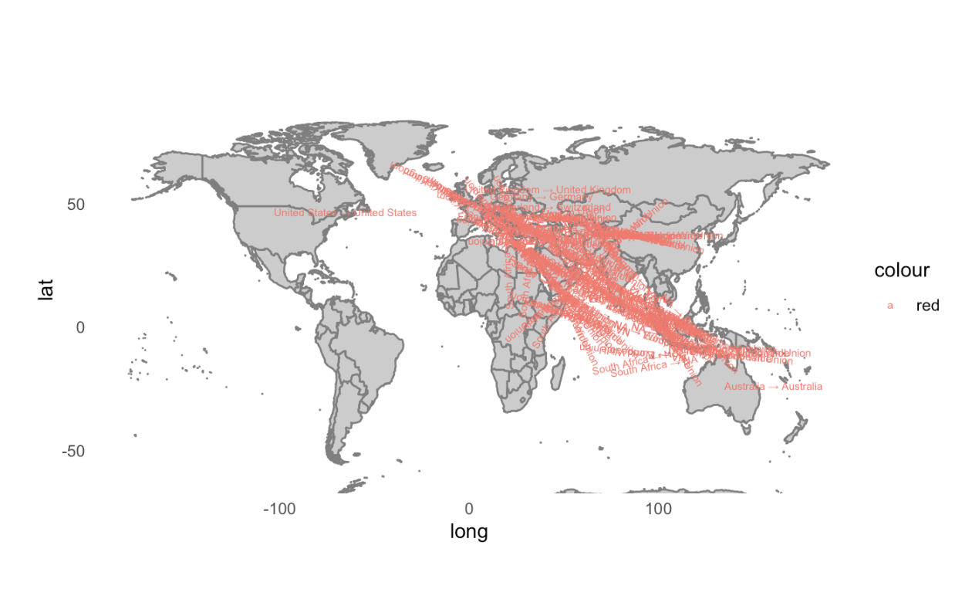

**Sankey Diagram: Routes for Cannabis (interactive)**

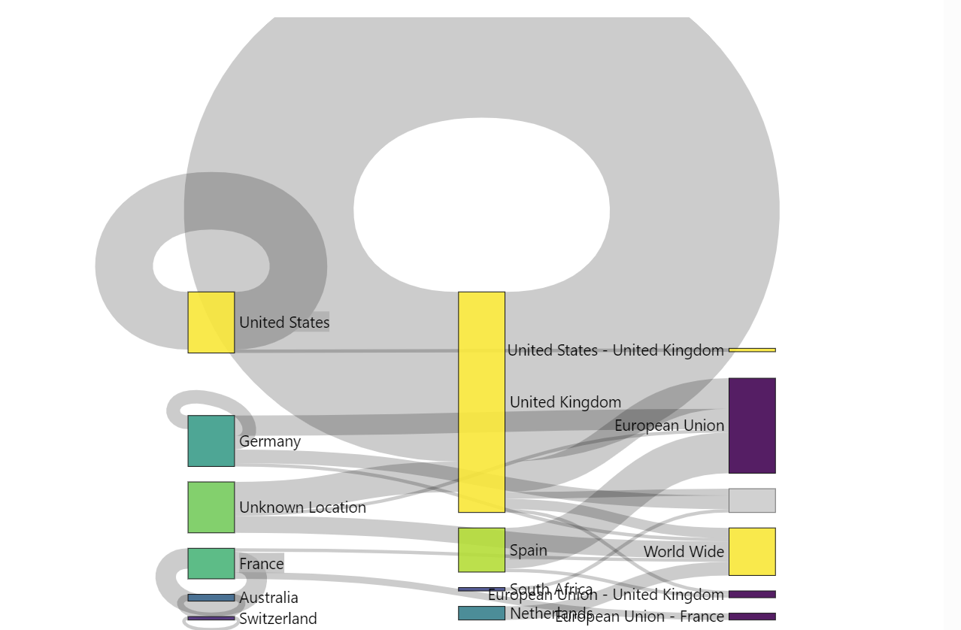

Again, I used Cannabis as an example. If you hover your mouse over the gray band, you can see the frequency of appearances of this transportation route in all drug-related advertisements. The wider the gray band, the more frequent the occurrence of this route. You can also move the blocks around if the words overlap. We can substitute Cannabis with other types of drugs and compare the differences. However, due to space limitations, we may not be able to include all the necessary diagrams in our publication. So, the following way of data visualisation might be more helpful.

**Top 5 routes for each type of drug based on the number of advertisements**

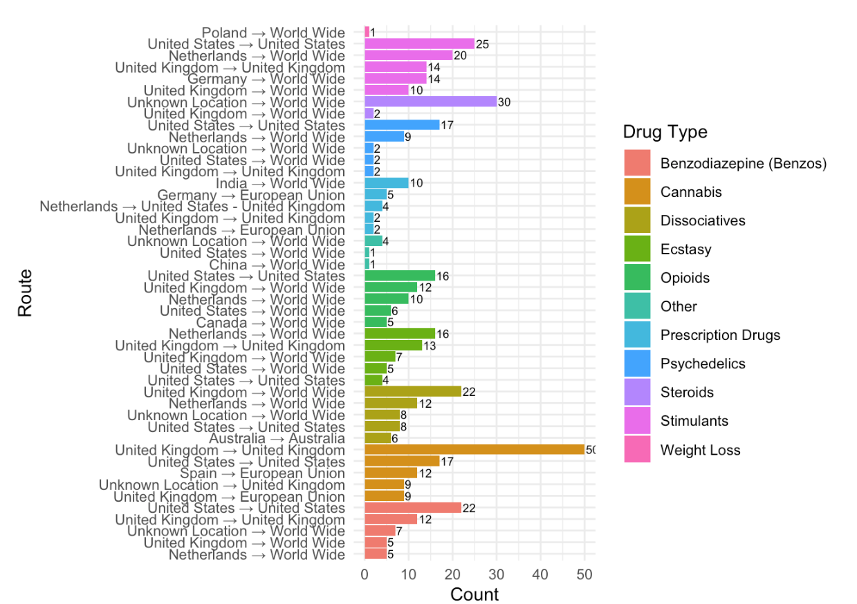

This diagram presents observations regarding the sending and destination locations for various drug types. The findings are as follows:

Benzodiazepines (Benzos): This drug type is primarily dispatched from the United States and the United Kingdom. The majority of shipments remain within their respective regions, while others are distributed globally.

Cannabis: Cannabis is predominantly sent from the United Kingdom, the United States, and Spain. Within the United Kingdom, there is significant domestic circulation, whereas the United States mainly receives shipments for its own region.

Dissociatives and Opioids: These two drug types are mainly dispatched from the United Kingdom, Netherlands, and the United States. They are distributed worldwide, although a portion is also sent to the sender’s own region, either the United Kingdom or the United States.

Ecstasy: Ecstasy is shipped worldwide, with the Netherlands serving as the primary sending location. The circulation volumes in the United Kingdom and the United States are relatively smaller.

Prescription Drugs: The diagram indicates that India is the leading sending location for prescription drugs, followed by Germany and the Netherlands. These drugs are sent to various destinations worldwide, including the European Union, the United States, and the United Kingdom.

Psychedelics: The diagram suggests that the United States is the primary sending location for psychedelics, followed by the Netherlands. The destinations for psychedelics encompass the United States, the United Kingdom, and other global locations.

Steroids: The majority of steroids originate from an undisclosed location, while the United Kingdom also plays a role in their distribution.

Stimulants: The data reveals that the United States is the primary sending location for stimulants, followed by the Netherlands and Germany. These drugs are dispatched to various destinations worldwide, including the United States, the United Kingdom, and other locations.

Weight Loss: Based on the available data, weight loss drugs are shipped from Poland.

In summary, the sending and destination locations vary for different drug types. Some drugs circulate primarily within specific regions, while others have a global circulation. However, the distribution of vendors appears to be concentrated within the UK and EU regions, with sporadic presence of US-based vendors. These insights can help us understand the circulation trends and market demand for different drug types.

**Themes**

***Review***

Again, I realise that these reviews are vendor-specific, so it is hard to know which product the reviewer is referring to if they don’t make it clear. The same reviews appear on posts with different vendor names and different drugs.

Firefly (00366, Pos. 8) selling Ketamine Solution

straightfromnl (00903, Pos. 8) Selling LSD

In the review section, it is common to ask vendors questions. However, several reviews have been removed (e.g. “deleted at 2022-04-23 16:59:51 UTC by /u/Francis” )

**Questions commonly asked:**

1. How to use the drug.

“Can I mix with drinks and use it (or) injection only?”

Can you please tell me how to use this product and if I need any other products to go along with this one? Does it need to be injected or applied directly to the skin? How much do I use per day? I purchased the product as a spray but it did not have a spray nozzle. It shipped with a screw on lid and the seal was broken. Thanks. (00314, Pos. 111-116)

1. Dosage and experience

How much to use? (100 mg are good for a K-hole experience?

How much would someone need to take of them to have an meth like effect? Or is this stuff totally different? How is it best consumed, just as a pill or crunched and snorted? Have no experience with it but want to try it (00887, Pos. 41-45) )

How are the Teslas? Do they give you a good clean roll? (01025, Pos. 58-59)

Have you tried squirting a bit of it up your nose with an oral syringe? (00314, Pos. 125)

1. Purity/Freshness

Are these oxys 100% nothing else In them? )

is it still fresh? I made a mistake of ordering from a vendor and he sent very dry,brittle weed. it was very lifeless to smoke y’a know? Thanks!)

1. Potency:

Is this the same as the other 30 mg oxy you sell? Is it strong or weak? I’m used to fentanyl so if I buy 1000 pills I want to make sure it will be strong (00926, Pos. 48-49)

1. Shipment (Delivery speed, location, successful delivery rate, when it arrives.)

e.g., Do you also ship to Italy? what’s the probability of successful delivery to india? whats the quickest u can get to the uk delivery please )

1. Availability

e.g. Have you got also ketamin 1000mg/10ml?

1. Whether it is acceptable to start with small transactions

(e.g., Is there any way I can maybe purchase like 50 so I can try your product out before committing to buying 500 or 1000. Is that possible? (01058, Pos. 97-99))

1. Asking for samples

Can you send any samples of your H so I can see what I like more ? Pls and thank u for ur time (00727, Pos. 36-38)

1. Asking for discounts

since you are a new vendor, are you offering any discounts on the carts?? (00669, Pos. 49))

1. The trustworthiness of the market

e.g. Is this a trusted market ? i really want to get these pills

1. Concerning about their own health: (00920, Pos. 64-79)

duece267 1 5 months ago

HOW MUCH FOR 10PC OF YOUR PERKS AND DO YOU KNOW IF ANY FENT IN YOUR PERKS...AINT TRYNA DIE OVER A PILL LOL

S1991 1 V OP 5 months ago

check review u gonna be sure of not being death man after ordering from me cuz

its fent free my bro

__ __

duece267 1 5 months ago

how much for 10 perks i believe you said can make custom orders like that

__ _

ko954 1 5 months ago

clean he aint lying

***Positive reviews***

The positive reviews are mostly about the quality and effectiveness of the products. The customers appreciate the generosity, trustworthiness, and reputation of the online vendor and fast shipping. The customers think that the vendor offers a decent price for top quality drug.

Hello friend, first of all, I would like to thank you very much for trusting me and for sending a sample of each product as generously as I expected. Then I am grateful for your silence on your word. Not even five or ten stars is less than you. For one thing, I haven’t tried anything of superior quality on your products so far. Really very high quality and effective products. When it comes to price, I think they deserve more, so you put a very low price on this quality. From now on I will definitely recommend you to my friends and relatives and from now on you are our Top seller. Congratulations again please keep you going like this. Best regards Orkan (00662, Pos. 155-166)

If you want top quality bars at decent price hit up cannedgoods on here it’s very fast shipping and always throw in a few extra D __ __ (00937, Pos. 85-89)

i get it.. quality was A+ D __ __ DeepDarkCasino2009 1 2 months ago very good…. shipping SUCKED.. quality of product A+ I (01025, Pos. 50-56)

Not my first purchase I’ve made from y’all, I made several purchases on world from you.. I’m looking for a . 5 gram of top shelf goods!! Thank you very much, for your time!!!! (00610, Pos. 33-35)

A customer shared his good experience, which can be used as a reference for other drug users in terms of dosage and effects.

Me and a friend had a trippy NYE with this tabs. I got some different tabs than showed on the pictures (the trader confirmed, that they would have the same dose), and each of us had 1,5 tabs. It was super intense and we laughed for hours. Can totally recommend! (00903, Pos. 77-81)

***Negative Reviews***

The negative reviews are mostly about the poor quality and low potency of the products. The customers complain that they had to take more than usual to feel any effect, or that the effect was too short or abysmal.

The customers accuse the vendor of writing their own reviews, or of sending them bad batches of products.

The customers hope that the online seller will get caught by the authorities, or that karma will get them.

The customers also express their anger and frustration about the slow or failed delivery of the products, or the risk of getting scammed or phished.

I tried the 3mmc of this trader before and have to say, that this was disappointing. Had to take the double for a nice effect, that only lasted 30 min. I don’t know if i might have gotten a batch that was not that good. (00902, Pos. 62-65)

there shit never shows up ive order from multiple sites from these guys cuz i trust vendors whove been around awhile. fuck these guys. hope they get there door kicked in. i believe n karma. i was low on money on the 3nd time they fucked me (00934, Pos. 78-81)

Bull shit !!!!! The fella rights his own reviews ! Don’t waste yomoney. Fast delivery - yes - quality - abysmal ! He probably got a shit few bars didn’t want to take the hit so he forward it to us to online mugs! (01092, Pos. 100-102)

i am lilou i had a bad experience yesterday so todai i try with the smallest item to see how is yout stuff and if i will not be phished lost 130e yesterday so i am not happy hope you can send it quickly i have problems with kleopatra it is not so easy as my former pgp (00929, Pos. 69-73)

***Extra info (soldiers are potential buyers of oxy)***

Hi you are buy far the best supplier and i need to make regular 80mg oxy orders for the injuries i suffered in Afghanistan, its been 12 days you asked me to wait for the tracking number would you mind sending it me straight away now so i can track if they will arrive today? as i a m in a lot of pain. I placed the order on the Royal Market and the order number was my Purchase - #sFuuOr was on 2022-12-16 13:35:23, I would be a loyal customer for life. (00923, Pos. 52-58)

Hi , I’m an Army Veteran of 15 years serving in Bosnia , Iraq and Afghanistan and was hit by an ied in Afghanistan fracturing my spine and leg and I’ve run out of my fentanyl patches early and in a massive amount of pain. I was hoping you could send me 28 x 8Omg oxycodone at £400 via Royal Mail 24 hour next day guaranteed delivery with the Saturday option as well so I will get them tomorrow if you can post today I am happy to send an extra £20 . Royal Mail says £16.99. I can order and pay now. Many thanks PJ. P (00923, Pos. 91-98)

**Customer Service**

1. Almost all vendors prioritise customer service and aim to answer messages as quickly as possible. Emphasising communication and problem-solving rather than punishing helps maintain a good reputation.
2. Providing Q&A (00958)
3. A nice feedback will be rewarded with some bonus on next order (e.g., 00309)
4. Regular buyers can get discount (e.g., 00232)
5. Many asked the buyer to consult with a message before leaving a negative review. (e.g., 01092)
6. Wholesale buyers can get a free sample (e.g., 01145).

**Refund/Reship**

Most vendors will provide partial or full refunds depending on the circumstances, such as sending the wrong product, incorrect quantity, or being detained. However, there are some suppliers who do not offer any refunds at all.

In the case of lost or detained orders, many suppliers will provide a one-time 100% reshipment service, especially for tracked orders within Europe. Orders outside of Europe usually only qualify for a 50% reshipment or a 25-50% refund.

Some vendors set conditions for returns and exchanges, such as:

1. Tracking must show that the order has not been delivered in order to qualify for reshipment/refund.
2. There is a minimum order requirement (ranging from 500 to 1500 euros) in order to receive a 100% delivery guarantee and compensation within Europe.
3. Only old customers (usually those who have placed 2 or more orders) are eligible for the reshipment/refund.
4. Due to the risk of seizure, the reshipment/refund policy is sometimes not available for certain countries with strict regulations.

Strategies used to increase the likelihood of repeat purchases.

1. Providing a generous reshipment policy (e.g. 100% reship/refund) to establish customer’s trust.
2. Improving the customer experience by offering fast delivery and clear estimated delivery time windows and using tracked shipping options for higher-priced international orders.
3. Limiting reshipment eligibility for loyal customers, which can encourage new buyers to complete multiple initial orders.
4. Preventing disputes by explaining all policies upfront and managing expectations on restrictions and risks of certain delivery methods.

Customers may not be eligible for a refund in the following situations:

1. If they provide an incorrect or incomplete address, or if there are issues with their previous address.
2. If tracking shows that the order has been delivered or returned to the sender.
3. If they claim to have received less items than they ordered or the package was empty, which is considered a fraudulent attempt.
4. If they are dissatisfied with the product quality or taste, as this is subjective and cannot be considered a valid reason for a refund.
5. If they leave negative feedback or raise a dispute without first contacting the vendor
6. If they order from a location outside of Europe, where there are higher transportation and customs risks
7. If they order through a non-tracked shipping method, as the delivery status cannot be verified.

**Interesting points without much data:**

Cultural elements in 01193

Please do not mistake my description of Poison as “Hard Sell”

In fact, I actively discourage certain people from buying it.

It is for the more refined, the more spiritual among us.

It is for those who create music, who write poetry.

It is for those who seek answers within.

It’s weed for living and loving life.

It’s food for the soul…

I like to think of it as the Zen of weed.

gratefullydead, the seller of Nbomes, attempted to defend the safey of using Nbomes through pointing out that The Nbome Death Scare is Fake News creatted by the Anti Drug effort (00088).

**Analysis based on DrugType?**

Please find the attached file: DrugType_CR.xlsx

**Limitations**

The data sample size is limited, and the time frame for data collection spans 11 days. However, trading was ongoing during this period, and variables such as ratings, the number of sales and reviews were constantly changing. These changes could impact the statistical data and comparisons. The sales data collected on day 1 from one vendor may differ significantly from the data collected from another vendor on day 11. However, if both sets of data were collected on the same day, the differences in sales data might not be as significant.

*Polish: Cebulka*

**Results**

**Drugs sold**

The research team coded 40 categories of drugs, and Table X indicates the top 13 drugs sold in Cebulka in 336 advertisements. Table X relates to the number of posts with a specific drug and the number of offers in total. As was mentioned before, in Cebulka, there could be different types of drugs in one post. We include this while reporting, noticing that this is especially so for cannabis and prescription drugs, as the vendors sell, e.g., hashish or marihuana, or have a rich offer when it comes to prescription drugs (24 types were identified, e.g., anticancer, antiviral, opioids, benzodiazepines, psychotropic drugs; no numbers are given here as these are less critical).

**Table X.** Number of posts with various drugs and number of offers for these drugs in total

|  |  |  |
| --- | --- | --- |
| **Category** | **Number of posts with a specific drug’s type** | **Offers in total** |
| cannabis | 172 | 420 |
| mdma | 69 | 102 |
| cocaine | 55 | 71 |
| amphetamine | 53 | 56 |
| prescription drugs | 48 | 1230 |
| lsd | 42 | 48 |
| 3/4CMC = clephedrone | 40 | 48 |
| 3/4MMC = mephedrone | 34 | 45 |
| ketamine | 29 | 35 |
| dmt | 21 | 39 |
| psilocybin mushrooms | 21 | 29 |
| metaamphetamine | 14 | 14 |
| designer drugs (e.g., HEX-EN) | 4 | 7 |
| TOTAL | 602 | 2144 |
|  |  |  |

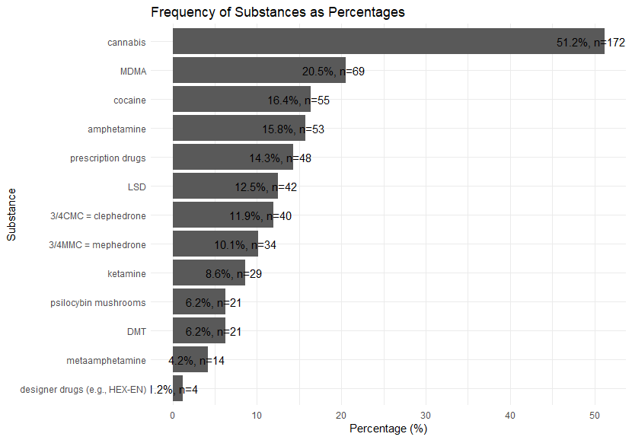

What is interesting, though, is that for both Cannabis and prescription drugs, the vendors seem highly specialized. Correlations indicating which drugs are sold more often together are visualized in Figure X. Only positive and statistically significant correlations are included, and only the top 13 drugs from Table X are correlated (the correlations are made for posts and not for offers in total). As is evident, cannabis and prescription drugs are not connected, unlike the other 11 types. The vendors seem thus highly specialized and focus either on cannabis, prescription drugs, or all other drugs.

**Figure X.** Which top 13 drugs are being sold together

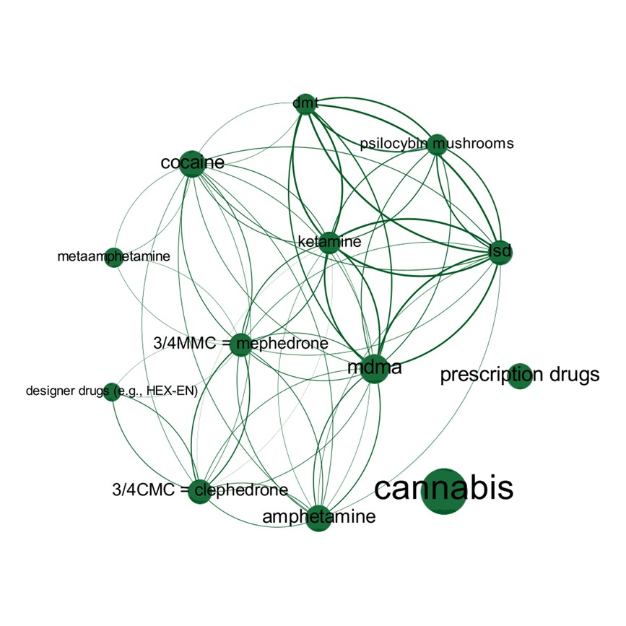

**The process of buying drugs**

Bitcoin and Monero are accepted, and the transactions are regulated by the general Cebulka’s rules and by rules given by each vendor alone. The general rules define several stages of selling the products. 1) Opening Escrow in the profile of a given vendor, then 2) selecting a payment option, and 3) filling out a short form including the title of the offer, the amount of Bitcoin or Monero involved, and an encrypted message about the details of the transaction. 4) the buyer must pay the deposit, and 5) the vendor must accept the order and ship the drugs. 6) Upon receiving, the user releases escrow, with some sellers having a stringent policy in this case, e.g., “if escrow is not released within 48 hours of receipt, the customer will never order anything again” (XXX). 7) After testing the product, the user should review the packaging, the shipment, and the quality of the goods using the vendor’s profile or comments. This is not a must, but a good rule. In the event of a transaction not being successful, the user has the right to file a complaint to the Admins, who resolve the so-called dispute.

Each vendor individually regulates other issues, e.g., there are no fixed rules regarding minimum prices or quantities sold. Generally, vendors are retailers, and in 82 offers, the wholesale could be agreed upon in private communication for interested buyers. All sellers give information on the shipping method, and most use the parcel lockers – a popular in Poland InPost services – and only some indicate Polish Post Office or other shipping companies like DPD. The word frequencies for the “shipping method” category identified 199 trigger words indicating the delivery takes place using parcel lockers (e.g., lemmatized “Inpost” or “paczkomat” (parcel locker in Polish), 65 words indicating Polish Post Office (e.g., lemmatized “Poczta” [Post Office], “list” [letter], “skrzynka” [mailbox]) and only 21 words indicating some other way of sending the package (e.g., lemmatized “Dpd” or “Dhl”). Apart from this, vendors also specify the cost of shipping and present various order templates, and some of them inform about the possible complaints, mainly referring to the general rules:

If you think what you received is of poor quality or not even what it should be, try to prove it in any way possible. Usually, a test for just a few zlotys is enough to have a basis for a claim. Unfounded negative reviews will be reported to the admins for removal. The competition is not sleeping, and we don’t want anyone to slander us (XXX).

**Trust and marketing**

One way of building trust is to give a detailed description of the drug. Table X shows subcategories indicated for the general “Description of the Drug” category, with the numbers relating to all offers, not the posts. As was previously mentioned, the posts often contain many offers of different drugs.

**Table X.** Subcategories indicated for the general "Description of the drug" category

|  |  |  |
| --- | --- | --- |
| **Description of the drug** | **The number for all offers** | **Percentage** |
| taste, smell, structure, color | 181 | 39,01 |
| results of using | 150 | 32,33 |
| country of origin | 70 | 15,09 |
| dosage | 41 | 8,84 |
| others | 22 | 4,74 |
| TOTAL | 464 | 100,00 |

Vendors strengthen their credibility by ensuring the high quality of the products sold, as is evident in the case of the word frequencies, which reveal several critical areas in this regard (Table X).

**Table X.** Top lemmatized trigger words related to the quality of the products sold

|  |  |
| --- | --- |
| **Trigger word** | **Hits in posts and the categories with the most hits** |
| “Czysty” (“pure”) | 153 hits in 54 posts.  Categories with the most hits: “results of using” (14 hits), and “taste, smell, structure, color” (10). |
| “Mocny” (“strong”) | 152 hits in 79 posts.  Categories with the most hits: “taste, smell, structure, color” (13), “results of using” (31), and “dosage” (7). |
| “Dobry” (“good”) | 246 hits in 84 posts  Categories with the most hits: “sales conditions” (34), “taste, smell, structure, color” (31), “results of using” (24), and “dosage” (7). |

However, information about laboratory testing and assessing and identifying the drugs’ composition is rare: “I personally tested this ephedrine in a laboratory. There is everything inside that needs to be there. The product is made in Romania and is imported from a pharmacy in Moldova” (XXX); “LSD is tested in a lab in the Netherlands, RSO – in a lab in Slovenia (a well-known lab)” (XXX). Netnographic exploration showed that since April 2023, sellers can obtain the status of a Certificated Vendor, valid for one year and approved by the Admins who test the selected products from the vendor’s offer. Sellers volunteer for the tests, and the results are published on the forum as a publicly available report. Netnography indicates that certificates did not arouse much interest, which may be because it is a new feature.

What is essential for the reputation of a given vendor is to guarantee the shipment’s safety, e.g., using multi-layered (anti-scan), odorless, sterile packaging, or applying OPSEC (Operational Security) procedures, e.g., not providing any phone numbers or using fake or temporary numbers for tracking orders, or using multiple measures to encrypt TOR traffic. Accessibility and communicability are also important, with most vendors preferring encrypted e-mails or Wickr messenger (see Table X for preferred communication).

Table X. Subcategories indicated for the general "Communication with the vendor" category

|  |  |  |
| --- | --- | --- |
| **Communication with the vendor** | **The number for all offers** | **Percentage** |
| e-mail | 243 | 50,31 |
| wickr | 190 | 39,34 |
| cebulka forum messages | 23 | 4,76 |
| jabber | 14 | 2,90 |
| threem | 7 | 1,45 |
| torchat | 2 | 0,41 |
| telegram | 2 | 0,41 |
| bitmessage | 1 | 0,21 |
| wire | 1 | 0,21 |
| TOTAL | 483 | 100,00 |

Marketizing the drugs could also mean giving discounts depending on the number of orders (18 such were identified for all offers), free samples (12), discounts for first users (11), discounts for users in exchange for positive feedback (10), free shipping (8), various sales (5), discounts for regular customers (4), competitions (2), discounts due to a newly opened business (2), etc.

As the netnographic part of the research shows, comments are an essential element of evaluating a given vendor. These can be found directly under the posts, but one can also reach them through the profile of each seller. Additionally, the profiles indicate the number of transactions, positive, negative, or neutral opinions, and the average rating for product packaging, contact and shipping, and product quality. In the comments themselves, users eagerly share their experiences, including describing their mental states, trips, or hallucinations, assessing the taste, smell, structure, appearance, or consistency of the drug, shipping time, etc. Some of the users even test the products bought:

I used the ProTest Kit (full test in several areas: Mecke - pass, Liebermann - pass, Mandelin - pass, Froehde - pass), checked it organoleptically, compared it to the S isomer which I have in stock from another Cebulka supplier and also to the R isomer which I also got from our forum - the quality is at a high level and denies the accusations from who is probably the competition.[1]

**Cebulka’s two-folded nature**

Cebulka has two-layers. The analyzed posts and offers are transactional in nature, Cebulka being an open platform, available to all registered users, who can freely purchase goods. There is little room for building relationships or participation there, as users mostly care about unproblematic transactions, security, and quality of goods, and vendors focus on these issues. The first and dominant layer is, therefore, the transactional one.

This does not mean, however, that the social/cultural dimensions are absent and that users and vendors are not building a specific community. For example, many vendors (recognize their regular customers based on handles: “I know all of you except BudfatherPL you Cebulka Guys. I remember some of the comments/and the summary of last year’s transactions that you ordered to @ [using email] I even have it in my notebook” (XXX). This second layer – the communal one – although signaled in such statements, is visible mainly in some side threads, i.e., not the offers. These side threats could be found in other sections of Cebulka, outside of the area dedicated to advertising drugs. However, the comments related to offers can often link to these side posts, allowing the exchange of information, experiences, and drug knowledge. For the present analysis, the nethnographic part mentioned in the Methodology section was the basis for exploring the content outside the offers, i.e., the comments and the side threads.

Cebulka could be then seen as more complicated than a pure trading platform. As previously indicated, when considering buying drugs, it is open and inclusive. However, there is a deeper level that can be seen as closed, exclusive, and accessed only by selected users. A good example is the thread with the so-called “Group 5” with the purpose “to bring close together people who contribute to the life of the forum, share unique information and their ideas …, and have something precious to offer.”[2] To join a thread (Group 5), one must be an active user with a long history of participating and contributing, and this is determined by the Admins who decide whether to grant access. The users note this is important as “the forum is … becoming more *exclusive*, especially that it won’t be long before it becomes *trendy* to use Cebulka.”[3]

The side threads are a space for the more advanced users, i.e., not only those who are transaction-oriented. Moreover, it is an area high in activity, with several messages published every day. Additionally, an essential element integrating the community is Admin-created surveys about possible changes on the forum, mainly regarding the transactions and promoting offers. The survey threads[4] show that the engaged users take Cebulka’s functionality very seriously and are happy to share their opinions. Hence, the board cannot be treated solely as a sales platform. This is often confirmed by the Admins, who emphasize the common goals of all involved in trading drugs:

Promote the anonymous use of networks such as Tor. Warn about new threats, software vulnerabilities, and disinformation [of law enforcers]. Don’t create divisions, help each other. Use constructive criticism and share your knowledge. A strong and united community defends itself more effectively in the constant fight against the enemy.

Helping each other, also by means of sharing various articles or guides, takes place in the section called “Alchemy,”[5] often referred to in the comments below offers. When finishing the study in August 2023, there were 141 threads in “Alchemy” with guides, tutorials, and articles shared by forum members. These focus on how to do, test, synthesize, or dose drugs.

The communal layer of Cebulka is also visible in the hierarchy of users. Admins (two in August 2023) moderate the forum. “Obserwatorzy” (Observers; 49,677 in August 2023) are of a lower status than “Cebulkowicze” (2,671), i.e., active users who can create new threads in each section, run surveys and rate other users. The promotion from Observer to Cebulkowicz is initiated either by buying the status or by applying for it. In the latter case, the process involves proving oneself through sharing valuable content, e.g., stolen (or not) data, software, books, documents, guides (e.g., creating step-by-step tutorials on drugs or darknet security), etc. It is the Admins and the whole community who assess the candidate based on the material they provide.

When describing this communal site of the board, the focus is on trading drugs. Although this is its central area, the users also trade or share stolen data, including credit card and bank account numbers, data related to social media profiles, or nude pictures stolen from others. While not determining whether these offers are scams or not, and not showing the scale of this trade, it must be stressed that these other areas seem to be even more communal oriented, as access to some of the content can be restricted based on the activities of users (e.g., the so-called transaction points, i.e., points received after successfully buying or selling on Cebulka). Hence, in the future, the scope of the research could be expanded.

**Vendors as specialists, physicians, psychologists**

Nethnography shows that some of the most popular vendors consider themselves competent, and experienced enough to help other users fight chronic diseases, including depression. Drugs are introduced as a relief and solace, and their effect could help one “feel relaxed at the end of the day and can provide relief from muscle spasms, pain, and stress.”[6] Drugs with low addictive potential are treated as alternatives to pharmacology, and vendors discuss their own experiences, probably to convince users and become more credible:

I have been struggling with depression for many years, and all the substances presented in the offer helped me and still help me regain the ground under my feet. When selling I cannot include amphetamines, methamphetamine, cocaine, opioids, benzos, and everything that can lead to serotonin, dopamine (…) tragedy. The offer is full of substances that are socially not harmful and with minimal risk of overdose, and I would like it to continue to be so, not for legal reasons but for my subjective reasons and general worldview[7]

In other words, sellers take on the role of a specialists with substantive knowledge to share with others:

Currently, the store works on an original guide to overcoming depression – this material will be made available on Cebulka – and it will be a substantive guide without nonsense and unnecessary amount of text – reflections after years of experiencing treatment from better and worse doctors and medicines.[8]

The reaction of users varies. On the one hand, they point out that daily use of, e.g., LSD or mescaline for depression is a short-term solution, not as effective as a long-term therapy, because “when it comes to fighting depression using psychedelics, it is just a temporary covering of the problem, e.g., for 4-5 days.”[9] They also believe that improper use of psychedelics may do more harm than good: “Such drugs can be your friend or your worst enemy. It depends on how you use them.”[10] On the other hand, some users list several benefits of alternative treatments, including increased creativity and brain neuroplasticity, and improved problem-solving skills:

I know someone who, thanks to microdosing, was free from a harsh depression (…) The first effects appeared after the first dose, the treatment lasted 3 months, and its effects have lasted for several years. I microdosed it myself for 2 months as an experiment, it ideally improves concentration.[11]

This role of vendors as specialists, physicians, and psychologists is another example of Cebulka’s communal layer. For some vendors, selling has a deeper meaning and is not only transactional. Apart from taking care of all the previously mentioned transactional elements of selling, they showcase particular views on drugs and convince buyers to share them. The vendors may succeed or not, as the users may agree or disagree, but nevertheless, the interactions and discussions add to a shared communal aspect of Cebulka.

**Discussion**

Our research clearly shows that sharing fact-based information and focusing on trading is the most important thing on sites specializing in the drug trade of the dark web. Cultural talk about issues and experiences related to use and drugs in general has moved to other forums.

The comparison made in this study only applies to dark web sites in the compared countries. It must be remembered that depending on the drug culture, in some countries drug dealing on clear web services such as Snapchat and Reddit is relatively common (see Demant, 2022) unlike in Finland and Poland.

**Conclusions**

We found different cultures and established measures for this.

**Acknowledgements**

Acknowledged the individuals who performed each task of the study. Acknowledge the institution that funded the study.

**References**

[1] Tsatti - Finnish discussions on Tor, Online 2023, http://tsattickdplsh2i2xqzlybvreiuppgoqsicmzkrotuudnk7h665ukgid.onion/

[2] Cebulka, Online 2023, http://cebulka7uxchnbpvmqapg5pfos4ngaxglsktzvha7a5rigndghvadeyd.onion/

[3] Nemesis Market, 2023, http://nemesis555nchzn2dogee6mlc7xxgeeshqirmh3yzn4lo5cnd4s5a4yd.onion/

Demant, J. (2022). An analysis of drug dealing via social media. EMCDDA, Demant_DrugsSocialMedia_2022.pdf

Haasio, A., Harviainen, J.T., & Hämäläinen, L. (2022). 'Biodynamically cultivated hash, confidentially': information sharing on the dark web. In Proceedings of ISIC: the information behaviour conference, Berlin, Germany, 26-29 September, 2022. Information Research, 27(Special issue), isic2241. Retrieved from http://InformationR.net/ir/isic22/isic2241.html (Archived by the Internet Archive at ...) https://doi.org /10.47989/irisic2241

Haasio, A., Harviainen, J. T., & Savolainen, R. (2020). Information needs of drug users on a local dark Web marketplace. *Information Processing & Management*, *57*(2), 102080.

Hakalahti, M., & Harviainen, J. T. (2021). Sharing identity information on Dark Web drug boards. *New Trends and Challenges in Information Science and Information Seeking Behaviour*, 49-58.

Harviainen, J. T., Haasio, A., Ruokolainen, T., Hassan, L., Siuda, P., & Hamari, J. (2021). Information protection in dark web drug markets research.

Kozinets, R. V. (2009). Netnography: Doing Ethnographic Research Online (1 edition). SAGE Publications Ltd.

1. http://cebulka7uxchnbpvmqapg5pfos4ngaxglsktzvha7a5rigndghvadeyd.onion/viewtopic.php?id=15486
2. <http://cebulka7uxchnbpvmqapg5pfos4ngaxglsktzvha7a5rigndghvadeyd.onion/viewtopic.php?id=322>
3. <http://cebulka7uxchnbpvmqapg5pfos4ngaxglsktzvha7a5rigndghvadeyd.onion/viewtopic.php?id=322>
4. See e.g. <http://cebulka7uxchnbpvmqapg5pfos4ngaxglsktzvha7a5rigndghvadeyd.onion/viewtopic.php?id=19558>; <http://cebulka7uxchnbpvmqapg5pfos4ngaxglsktzvha7a5rigndghvadeyd.onion/viewtopic.php?id=18767>; <http://cebulka7uxchnbpvmqapg5pfos4ngaxglsktzvha7a5rigndghvadeyd.onion/viewtopic.php?id=16696>.
5. <http://cebulka7uxchnbpvmqapg5pfos4ngaxglsktzvha7a5rigndghvadeyd.onion/viewforum.php?id=21>
6. <http://cebulka7uxchnbpvmqapg5pfos4ngaxglsktzvha7a5rigndghvadeyd.onion/viewtopic.php?id=15628>
7. <http://cebulka7uxchnbpvmqapg5pfos4ngaxglsktzvha7a5rigndghvadeyd.onion/viewtopic.php?id=12886%20>
8. <http://cebulka7uxchnbpvmqapg5pfos4ngaxglsktzvha7a5rigndghvadeyd.onion/viewtopic.php?id=12886&p=2>
9. <http://cebulka7uxchnbpvmqapg5pfos4ngaxglsktzvha7a5rigndghvadeyd.onion/viewtopic.php?id=12886&p=2>
10. <http://cebulka7uxchnbpvmqapg5pfos4ngaxglsktzvha7a5rigndghvadeyd.onion/viewtopic.php?id=12886&p=2>
11. <http://cebulka7uxchnbpvmqapg5pfos4ngaxglsktzvha7a5rigndghvadeyd.onion/viewtopic.php?id=12886&p=2>